Chapter 2

Counselor Skills/Qualifications

Scope of chapter. This chapter discusses the qualifications, skills, and abilities required for staff and volunteers working as Benefits Counselors I. The Benefits Counseling program, known as the Health Information Counseling and Advocacy Program (HICAP), is established as a basic program of the Area Agencies on Aging pursuant to funding received from the Texas Health and Human Services Commission. HICAP is funded by a State Health Insurance Assistance Program (SHIP) grant from the Administration for Community Living (ACL). In Texas, in addition to SHIP activities, the HICAP program carries out activities under the Medicare Improvements for Patients & Providers Act (MIPPA).

Overview of Sections

- Section 1 Source of Medicare law regarding HICAP.
- Section 2 Allowable activities as defined by ACL for the SHIP (HICAP).
- Section 3 SHIP topics and MIPPA topics
- Section 4 Benefits Counselor Certification.
- Section 5 SHIP Volunteer Risk and Program Management Policy Implementation Manual.
- Section 6 HICAP training topics.
- Section 7 Chapters 3 through 7 of the HICAP Benefits Counseling Manual.
- Section 8 Other Training Requirements.
- Section 9 Outreach Activities.
- Section 10 Monitoring.
- Section 11 Quality Assurance.
- Section 12 Serving Beneficiaries with Mental Illness.
- Section 13 Customer Satisfaction Survey
- Section 14 Safeguarding of Personal Information of Clients.
- Section 15 Availability of Texas Legal Services Center.

- Appendices

  - A – Texas Health and Human Services Commission’s “Allowable Activities Chart”
  - B – Certification Forms
  - C – SHIP Volunteer Risk and Program Manual
  - D – Home Visit Considerations
  - E – Client Intake and Service Request Form
  - F – Client Rights and Responsibilities
  - G – Area Agency on Aging Client Information Release

- Source of Medicare Law for the SHIP (HICAP)

The Medicare law at 42 United States Code § 1395b-4 Health Insurance Information, Counseling, and Assistance Grants: provides in part:
  - Grants. The Secretary of Health and Human Services (in this section referred to as the "Secretary") shall make grants to States, with approved State regulatory programs under section 1882 of the Social Security Act [42 USCS § 1395ss], that submit applications to the Secretary that meet the requirements of this section for the purpose of providing information, counseling, and assistance relating to the procurement of adequate and appropriate health insurance coverage to individuals who are eligible to receive benefits under title XVIII of the Social Security Act [42 USCS §§ 1395 et seq.] (in this section referred to as "eligible individuals"). The Secretary shall prescribe regulations to establish a minimum level of funding for a grant issued under this section.

The individuals to be served by the SHIP are “individuals who are eligible to receive benefits under title XVIII of the Social Security Act” – which is to say, individuals eligible to receive Medicare benefits.

It should be noted that “an individual eligible to receive Medicare” includes persons on Medicare regardless of age. Certain individuals, such as those who have received 24 months of Social Security Disability Insurance Benefits (SSDI), those who have end-stage renal disease, and those who have Amyotrophic Lateral Sclerosis (ALS) (Lou Gehrig’s disease) and are receiving disability benefits from Social Security or the Railroad Retirement Board, can receive Medicare, even though they may be many years younger than age 65. Such individuals can be served by the Benefits Counseling program.
- Allowable SHIP Activities

Allowable SHIP activities include outreach, counseling and training regarding Medicare Part D (including Eligibility/Screening, Plan Comparison, Enrollment, Disenrollment, Plan Non- renewal, Low Income Subsidy/Extra Help Application Assistance); Medicare Parts A & B (including Application Assistance); Medicare Advantage (including Eligibility/Screening, Plan Comparison, Enrollment, Disenrollment); Medicare Appeals (non-court level); Medicare Supplement/Select (including Plan Non-Renewal, Eligibility/Screening, Plan Comparison); Medicaid (including Plan Non-renewal, Medicare Savings Program Screening, Medicare Savings Program Application, and Medicaid Screening). Outreach and enrollment services regarding the Low-Income Subsidy (LIS)/Extra Help and regarding the Medicare Savings Program can also be provided with funding under the Medicare Improvements for Patients and Providers Act (MIPPA), and thus they are not exclusively available as SHIP services.

MIPPA services include Outreach and Enrollment services regarding Medicare Preventive services, Medicaid Application Assistance, Medicaid Benefit Explanation, Medicaid Buy-in Coordination, Medicaid Eligibility/Screening, and Medicaid Application Submission, Medicare Savings Program Application Assistance and Recertification Assistance. MIPPA services include, in regard to LIS/Extra Help, the following: Application Assistance, Application Submission, Benefits Explanation, Eligibility/Screening, and Limited Income Newly Eligible Transition Program (LI NET); and the Best Available Evidence (BAE) policy of the Centers for Medicare and Medicaid (under which Part D sponsors must provide access to Part D drugs at the correct LIS cost-sharing level when presented with evidence of LIS eligibility, even if the sponsor’s systems and CMS’ systems do not yet reflect that eligibility). Services regarding public benefits that are not listed as SHIP services are considered Legal

Assistance under Title III B of the Older Americans Act; they cannot be provided as SHIP services.

Legal Assistance (not allowable SHIP services) are services regarding Advance Directives, Defense of Guardianship, Housing (tenant’s rights), Foreclosure/Eviction, Long- term Care, Economic Security, Age Discrimination, Income, Utilities (Low Income Home Energy Assistance Program and weatherization programs), and Exploitation, Abuse, Neglect and Fraud, including but not limited to elder abuse. Legal Assistance under Public Benefits and Appeals regarding health care and nutrition include County Assistance Programs, SNAP, TANF, Health Care and Support Services, Medicare Appeals (court level) and Medicaid Appeals (non-court and court level).

- SHIP Topics, MIPPA Topics, and Legal Assistance Topics

SHIP, MIPPA and Legal Assistance topics (which are not allowable SHIP services) are listed in the Texas Health and Human Services Commission’s “Allowable Activities Chart” (Appendix A).

- Benefits Counselor Certification.

- Overview of Benefits Counselor I certification.

The Texas HICAP program requires the certification of Benefits Counselors. To gain certification as Benefits Counselor I, individuals are required to participate in training, work under supervision, and to pass a test. Benefits Counselor Level I (SHIP Benefits Counseling) require 25 hours of training, 20 hours of client counseling services under supervision, and passing a 100-question written test with a score of 70% or better. The Texas Legal Services Center course entitled Benefits Counselor I, 13.75 hours is required training.
When the applicant has completed the 25 hours of training and 20 hours of client counseling services under supervision, the Application and Verification form provided in Appendix B is completed and sent to BCtraining@tlsc.org, requesting a test. The Application and Verification form must be completed in full, listing with specificity the 25 hours of training and the 20 hours of supervised counseling, so that a review can take place. The simple reading of source materials alone will not count as hours toward certification. Texas Legal Services

Center may request supporting documentation. After taking the BC I training, one year is allowed to complete all 45 required training/counseling hours to submit the Application and Verification form with BCtraining@tlsc.org and request the test for certification.
The forms require signatures of the applicant and AAA and or ADRC Director, certifying that those hours are accurate and earned.
The Director of the Area Agency on Aging and or Aging and Disability Resource Centers or their designee requests the Benefits Counselor I test from Texas Legal Services Center and administers it to the Benefits Counselor seeking certification. Once completed, the test is returned to Texas Legal Services Center who will then score it. The Benefits Counselor must be supervised in Benefits Counseling by the Area Agency on Aging. Benefits Counselors report into the State Unit on Aging Programs Uniform Reporting System (SPURS) for Services. Thereafter, an Application Programming Interface (API) exports the information from SPURS to the SHIP Tracking and Reporting System (STARS). A Benefits Counselor will need to submit directly to HHSC a user request with the CMS Unique ID for access to SPURS and the SPURS Change Request form with STARS access Confidentiality Agreement for Receipt of CMS Unique ID found at https://www.tlsc.org/hicap. An ADRC Benefits counselor will submit a STARS access form only to HHSC.

- Forms and Test for certification.
The Application and Verification form for certification is found at https://www.tlsc.org/hicap and is the only form that will be accepted.
The Benefits Counselor I candidate takes the test under the following conditions:
- It is a 100 question, proctored test. 70% is passing.
- It is an "open book" test, and they may access materials on-line.
- The submission of this test is their certification that:
  - The test was completed in one eight-hour day;
  - The BC did not "google the answers”
  - The BC used the on-line resources learned of during training; and
    - The BC answered all the questions without the assistance of others

- After the Test is passed.
Texas Legal Services Center receives and scores the completed test. If the score is passing (70% or better), a certificate and badge are prepared for signature by the Texas Health and

Human Services Commission. Once Texas Legal Services Center receives the signed certificate and badge from the Texas Health and Human Services Commission, the signed certificate and badge are sent to the Benefits Counselor’s Director.
If the Candidate does not pass the test, they will have an opportunity to take the test one more time within a 3-month period. If the test is not passed on the second try, the director should contact TLSC to discuss having the candidate take the training again.

- Benefits Counselors who are volunteers and employed by a service provider or outside agency. Volunteers can be a very valuable addition to an Area Agency in assisting member of the public with Benefits Counseling. While not paid by an Area Agency, the Agency must vouch
for an individual volunteer and be responsible for their conduct while acting as Benefits Counselor. Care must be taken that a volunteer becomes a Benefits Counselor to assist persons in any given Area Agencies region for the primary benefit of the public and for the AAA. A volunteer should not become a Benefits Counselor to further his or her own interest such as gaining client business for themselves or for associated entities. Volunteers acting as Benefits Counselors who are employed by outside service providers or related agencies must sign a statement as follows: “I agree that the interest of my client is primary. If there are interests of my employer that conflict with that of my client, I will inform my client of the nature of the conflict and I will offer my client a referral to another Benefits Counselor who does not have a conflict.” The Benefits Counselor volunteer needs to report the conflict of interest to their supervisor and then the supervisor will work on resolution to the conflict.

- Benefits Counselor relocating to a Texas Area Agency on Aging from another state. On occasion, an individual who has been certified as a Benefits Counselor by a SHIP in a different state relocates to Texas and works or volunteers for a Texas Area Agency on Aging. If the candidate can show they went through 25 hours of SHIP training and 20 hours of supervision in the other state and if the individual takes and passes the 100-question test used in the Texas HICAP program, the individual can be certified as a Benefits Counselor in Texas. The forms in Appendix B must be submitted verifying training and mentoring hours to complete the certification of such an individual.

- Additional HICAP training can lead to additional certifications.

Additional certifications available to those who are Benefits Counselors I are as follows:

  - Benefits Counselor Level II is based on a day of training on legal research, the appeals process and document preparation. There is no written test required for certification. Instead, an applicant will have to participate in a mock hearing during which the Benefits Counselor represents a mock client (who is usually a different Benefits Counselor). The applicant will meet with TLSC staff several days before the mock hearing to go over basics and to clear up any procedural questions, The applicant is then provided with a written case scenario, steps to introduce an exhibit and checklists to track their actions. In the mock hearings, the roles of witness and advocate may be played by Benefits Counselors, switching from one role to the other between iterations of the mock hearing. This training is open to the BC I with a current and unexpired certification. At the conclusion of the training, all attendees will be scheduled for a Mock Pre- Hearing and Mock Hearing. Upon successful completion of the Mock Hearing, the applicant will file the Application and Verification requesting BC II certification. The Verification will list the one day of training, the day of the Mock Pre-Hearing, and the day of the Mock Hearing, for a total of 8 hours. The 8 hours may be listed in support of the 12 hours required for recertification.

  - Long-Term Care Planning Certification requires that a Benefits Counselor be currently certified as a Level I, and then participate in a minimum of one and a half days of training ending with a written examination that must be passed with a score of 70% or better. At the conclusion of the training, all attendees will be scheduled to take the test.
  - Advance Directive Preparer certification (which thus are not allowable SHIP services) requires that a Benefits Counselor be currently certified as a Level I Benefits Counselor, participate in a day of training, and pass a written test with a score of 70% or better. Recognizing that laws change, this certification is effective for two years, after which the Benefits Counselor must train again to renew the certification.

- Trainings via webinar.

Currently, the Texas Health and Human Services Commission, has approved any HICAP training offered by Texas Legal Services Center can be accomplished by webinar. The mock hearing for Benefits Counselor II certification, which includes the actual administrative law hearings surrounding benefits, is normally conducted by distance means (video or telephone).

- An Area Agency on Aging is required to give notice of termination.

It is the responsibility of an AAA to give notice of the termination of any counselors. Notice is to be given to Texas Legal Services Center within 15 days of the termination of a Benefits Counselor to BCtraining@tlsc.org . TLSC should also notify the State Unit on Aging (SUA) to update any records related to the certified benefits counseling list.

- Benefits Counselors are required to maintain certification
It is the responsibility of the Benefits Counselor and director to track an individual’s certification expiration dates.
To maintain certification as a Benefits Counselor I, Benefits Counselors must attend a minimum of 12 hours of training during each two-year period. Hours earned outside the two- year period of certification will not be accepted in support of recertification.
A request for recertification is made by timely filing an Application and Verification, listing the 12 hours of training. The request to recertify should be filed the month before expiration and sent to BCtraining@tlsc.org .
If the Application and Verification are filed in the expiration month, there may not be sufficient time to review and recertify before expiration, resulting in a lapse in certification.
A 90-day grace period will be given after expiration to complete the recertification process. If this is not completed within the grace period, a Benefits Counselor will need to re-take the BC I training and complete other hours to fulfill the original 25-hour requirement.
Recertification for Level I do not require taking another test but it does require the minimum of 12 additional hours of training during each two-year recertification period. To maintain

certification (once achieved) for Benefits Counselor II, or Long-Term Care Planning, or Advance Directives Preparer, (which thus are not allowable SHIP services) the Benefits Counselor must maintain certification as a Benefits Counselor I. An award of BC II, Long- Term Care Planning or Advanced Directives Preparer does not serve to restart the two-year certification, but the hours earned for these trainings may be applied to the 12 hours required.

- SHIP Volunteer Risk and Program Management Policy Implementation Manual

Volunteers are very important to the HICAP program, be it for SHIP services, MIPPA services, Legal Assistance, or all three. Appendix C is the SHIP Volunteer Risk and Program
Management Policy Implementation Manual. Volunteers who go through the same certification steps as staff can be certified for any of the HICAP certifications.

- HICAP (SHIP) Training Topics

Areas of knowledge necessary to the work of Benefits Counselors I are covered in Chapters 4 through 7 of the HICAP manual which focus on SHIP topics. The Benefits Counselor applicant may ask their Director or TLSC for suggestions regarding the appropriate 25 hours of training. The CMS Medicare Learning Network and the SHIP TA Center are appropriate sources of training. Each AAA has access to training suites which include modules with PowerPoint presentations, exercises, games, tutorials, and DVDs to use in training and presenting to beneficiaries. The Medicare program also produces numerous publications on Medicare Parts A, B, C, D, and related topics. For actual case handling, the Medicare program maintains unparalleled substantive manuals and claims processing manuals, now online, that answer even the most detailed questions encountered in serving a Medicare beneficiary.

- Chapters 3 through 7 of the HICAP Benefits Counselor Manual.

Following is a description of Chapters 3 through 7 of the HICAP Benefits Counselor Manual. Description of private insurance and public health programs are covered in Chapters 3, 4, 5, 6, and 7 in the Manual. These chapters are aimed at building a counselor’s skills and subject knowledge regarding Medicare.

- Chapter 3 provides a Benefits Counselor tools to gather the information that will be essential to helping a client obtain services they need. Intake forms and sample narratives help counselors who may not have experience in interviewing. This chapter also sets expectations for how to report the activities performed.
- Chapter 4 addresses Medicare as a federal health program. It covers the health benefits available under Medicare Part A, Part B, and Part D known as the Medicare Prescription Drug Program. It also explains receiving benefits from the traditional Medicare health plan versus Medicare Advantage, Part C, private health plan options. It includes information on eligibility and enrollment.
- Chapter 5 introduces out of pocket costs associated with Medicare and identifies other insurance options to supplement Medicare. The chapter covers group insurance and Medicare Supplement policies. Also covered are rights and protections when someone loses health coverage through no fault of their own.
- Chapter 6 presents information about the public government health programs available to help pay Medicare costs for persons with limited income and resources. This chapter explains Medicaid, the Medicare Savings Programs and the Low-Income Subsidy for Medicare Part D.
- Chapter 7 explains fraud and abuse in the Medicare program and other insurance fraud that falls under the authority of the Texas Department of Insurance.

- Other training requirements. Benefits Counselors I are required to be proficient in problem solving beyond having a basic understanding of private and public programs. The expansion of Medicare health plans and the prescription drug plans, require specialized training to understand rules unique to each type of plan. Additionally, some problems presented by clients, may require special case work. An example of this includes using online Medicare plan comparison tools (including the plan finder) and reviewing a client’s complaint to determine if there is a marketing violation or a right to a special enrollment. The Benefits Counselor I training of the Texas HICAP program includes a demonstration of the plan finder. As noted, CMS and the SHIP TA Center offer additional training.

- Outreach Activities

- Local Benefits Counseling programs are encouraged to maintain an overall awareness of, and work with, other existing service agencies. These include agencies such as health departments, clinics, and organizations seeking to help beneficiaries access Medicare. Benefits Counseling programs should maintain a referral process to appropriate programs and offices. Partnering with mental health and disability services providers can be especially
useful to many beneficiaries.

- In a screening process, there are additional resources and agencies that benefits counselors may utilize to assist individuals in exploring eligibility for benefits. One thorough screening tool can be found by visiting Medicare.gov.

- Counseling programs are encouraged to make adequate services available to clients in the entire AAA service area. Providing training to other aging and health providers helps to maximize the resources of local programs.

- Local Benefits Counseling programs should take advantage of resource materials and consumer publications aimed to inform and educate individuals about the benefits to which they are entitled. Benefits Counseling programs can order brochures in bulk from CMS.

- Home visits to beneficiaries who are not able to leave their homes can be an important outreach tool. A list of considerations regarding home visit issues is at Appendix D.
- Monitoring. The Benefits Counseling program, as a program of the AAA, is subject to monitoring by HHSC. It is subject to ACL review, and performance reporting through the SHIP Tracking and Reporting System (STARS), as well as quality assurance activities meant to evaluate the program.

- Quality Assurance for SHIPs. Quality assurance activities are becoming of increasing importance in the SHIP program. Although states’ Benefits Counseling programs are structured differently throughout the country and in U.S. territories, there are core SHIP services. For instance, all SHIP programs provide timely and accurate information and must demonstrate a capacity to provide services to the areas they serve.

- Training to serve Beneficiaries with Mental Illness. CMS provides training modules to promote outreach and assistance to beneficiaries with mental health conditions. The Medicare Learning Network has a module on mental services that are covered by Medicare.

- Customer Satisfaction Survey. ACL has requested that SHIPs administer a survey designed to gather input from individuals who receive recent SHIP Medicare counseling. Individuals who receive counseling during a set survey administration period should be informed that they may receive a call regarding the counseling services they received. The purpose of the survey is to measure satisfaction with SHIP Medicare counseling services, to assess how customers value the services and information they receive, to identify opportunities for continuous improvement, and to comply with regulatory requirements regarding data collection and continuous improvement.

- Safeguarding of Personal Information of Clients. HHSC and ACL mandate that Benefits Counseling programs safeguard personal client information and disclose, per federal and state rules, privacy measures to their clients. The following forms are samples of documents aimed at documenting compliance.
- Client intake form used to gather personal information needed to screen the applicant for services requested and other programs. See Appendix E - Client Intake and Service Request Form.
- Client Agreement forms are used during intake and aimed at explaining Benefits Counseling services and use of personal information. See Appendix F – Client Rights and Responsibilities Form.
- HIPAA compliant release form necessary to obtain information from Medicare contractors and Medicare health and prescription plans. See Appendix G – Area Agency on Aging Client Information Release form.

- Availability of Texas Legal Services Center

Staff of Texas Legal Services Center are available to answer any questions about the HICAP Benefits Counselor certification process and to answer requests for training.
Such questions and requests can be answered through BCtraining@tlsc.org.

Staff of Texas Legal Services Center are available to provide legal and technical assistance to Benefits Counseling and Ombudsman staff of AAA’s and ADRC’s on issues involving individual client cases and on matters relating to public/private benefits and related legal issues.
Texas Legal Services Center is the owner and manager of the Texas Advocates google group. The group description is as follows: This is a listserv for the personnel (staff and volunteers) who provide services through the Texas Area Agencies on Aging, the Texas Department of Health and Human Services Commission - Access and Eligibility Services (HHSC-AES), and through the Texas Legal Services Center.
A request to be added to the google group must be made by the Director or come from an Area Agency on Aging email address. The Director is to notify TLSC when a Benefits Counselor leaves service so that they can be removed as a member of the group. Requests and notification are to be sent to BCtraining@tlsc.org .
Texas Legal Services Center provides legal assistance to Medicare Beneficiaries through the Legal Hotline for Texans. The number for client service from the Legal Hotline for Texans is 1-800-622-2520 x3.

Appendix A
Texas Health and Human Services Commission
Allowable Activities Chart

Texas Health and Human Services Commission Allowable Activities Chart

State Health Insurance Assistance Program Outreach, Counseling And Training | Medicare Improvements for Patients and Providers Act Outreach and  Enrollment | Legal Assistance – Falls under Title III-B Services (which thus  are not allowable SHIP services)
Medicare Part D: | Low Income Subsidy/Extra Help | Public Benefits and Appeals (Health care and Nutrition)
- Eligibility/Screening | - Application Assistance | - County Assistance  Programs
- Plan Comparison | - Application Submission | - SNAP, TANF, Health Care, and Support Services
- Enrollment | - Benefit Explanation | - Medicare Appeals  (court level)
- Disenrollment | - Eligibility/Screening | - Medicaid Appeals  (non-court and court level)
- Plan Non-renewal | - Limited Income Newly Eligible Transition Program  (LI NET) | Advanced Directives
- Low Income Subsidy/Extra Help Application Assistance | - Best Available Evidence (BAE) Policy of CMS | Defense of Guardianship
Medicare Parts A & B: | Medicare Savings Program | Exploitation, Abuse, Neglect, and Fraud (including but not  limited to domestic abuse)
- Application Assistance | - Application Assistance | Foreclosure/Eviction
Medicare Advantage | - Recertification | Housing
- Eligibility/Screening | Medicare Preventive | - Tenant Rights
- Plan Comparison | Medicaid | Long-term Care
- Enrollment | - Application Assistance | Economic Security
- Disenrollment | - Benefit Explanation | Age Discrimination
Medicare Appeals (non-court level) | - Buy-In Coordination | Utilities
Medicare Supplement / Select: | - Eligibility/Screening | - Low Income Home Energy Assistance Program  (LIHEAP)
- Plan Non-renewal | - Application Submission | - Weatherization Programs
- Eligibility/Screening |  | Income
- Plan Comparison
Medicaid
- Plan Non-renewal
- Medicare Savings Program
- Medicare Savings Program
Application
- Medicaid Screening

Revised 7.22.20

Appendix B Certification Forms

Application and Verification for HICAP Benefits Counselor Certification

APPLICANTS NAME:
PHONE NO.:
EMAIL ADDRESS:
AREA AGENCY ON AGING:
DIRECTOR:

I request approval to become a certified Benefits Counselor I for the Texas Health Information, Counseling and Advocacy Program (HICAP). I agree to abide by the rules, policies and procedures governing this program, including reporting requirements, as set forth by the Texas Health and Human Services Commission. I agree to accept supervision and direction from the area agency and its staff benefits counselor. I agree to perform my duties in a consistent and faithful manner and to maintain the need and rights of older people as a priority for my efforts.

I understand the need to maintain confidentiality of any and all personal information I receive in the course of my duties as benefits counselor.

I agree to notify the staff benefits counselor and area agency of any conflicts of interest that exist or may develop during the course of my duties.

I agree that the interest of my client is primary. If there are interests of my employer that conflict with that of my client, I will inform my client of the nature of the conflict and I will offer my client a referral to another Benefits Counselor.

Please Note: The steps required for certification must be completed before this form is submitted.

Please check that you have completed the following requirements:

Benefits Counselor I:
25 hours required training (list the training hours on page 3).

20 hours client counseling, with oversight (list the counseling hours on page 4).

- I am requesting the Benefits Counselor 1 test, to be administered by TLSC.

- The applicant is (check all that are applicable):

an employee of the Area Agency on Aging a volunteer of the Area Agency on Aging

an employee of the Aging and Disability Resource Center of

a volunteer of an Aging and Disability Resource Center of

an employee of an agency or entity other than an Area Agency on Aging or an Aging and Disability Resource Center.

The employer of the applicant is: Name:

Address:

25 Hours of Training

Course name and name of provider | Date | Hours
BC 1 HICAP three-day training (required)  - Texas Legal Services Center |  | 16.00
 |  | Total Hours:

Page | 3 of 4
Revised 10/2022

20 Hours of Supervised Client Counseling

Name of Supervisor and Topic counseled on: | Date | Hours
 |  | Total Hours:

Page | 4 of 4
Revised 10/2022

“My name is . I am the applicant and I verify that the information listed are true and correct.”

APPLICANT SIGNATURE DATE

The Director verifies that the 25 hours of training listed on page 3 and 20 hours supervised counseling listed on 4 by the applicant are true and accurate. The Director further verifies that the applicant does not present a conflict of interest with the HICAP program.

DIRECTOR, AREA AGENCY ON AGING

DATE

Submit this completed form to BCtraining@tlsc.org

Application and Verification for HICAP Benefits Counselor II, Long-Term Care, and Advance Directive Preparer Certification

APPLICANTS NAME:
PHONE NO.:
EMAIL ADDRESS:
AREA AGENCY ON AGING:
DIRECTOR:

I request approval to become a certified
- ☐ Benefits Counselor II,
- ☐ Long-Term Care Planning, or
- ☐ Advance Directive Preparer
for the Texas Health Information, Counseling and Advocacy Program (HICAP). I agree to abide by the rules, policies and procedures governing this program, including reporting requirements, as set forth by the Texas Health and Human Services Commission. I agree to accept supervision and direction from the area agency and its staff benefits counselor. I agree to perform my duties in a consistent and faithful manner and to maintain the need and rights of older people as a priority for my efforts.

I understand the need to maintain confidentiality of any and all personal information I receive in the course of my duties as benefits counselor.

I agree to notify the staff benefits counselor and area agency of any conflicts of interest that exist or may develop during the course of my duties.

I agree that the interest of my client is primary. If there are interests of my employer that conflict with that of my client, I will inform my client of the nature of the conflict and I will offer my client a referral to another resource for Benefits Counseling.

Please Note: The steps required for certification must be completed before this form is submitted.

- Please check one of the following four categories:

  - Benefits Counselor I – Current certification period: from to .

  - Benefits Counselor II – Current certification period: from to .

    - For Benefits Counselor II Only: Date of TLSC training for BC II: Date of passed mock hearing:
  - Long-term Care Planning Certification
- Date of TLSC training:
- Date of when you passed test:

  - Advance Directive Preparer Certification:
- Date of TLSC training:
- Date of when you passed test:

- The applicant is (check all that are applicable):
an employee of the Area Agency on Aging a Volunteer of the Area Agency on Aging
an employee of the Aging and Disability Resource Center of

a volunteer of an Aging and Disability Resource Center of

an employee of an agency or entity other than an Area Agency on Aging or an Aging and Disability Resource Center. The employer of the applicant is:

Name:

Address:

“My name is . I am the applicant and I verify that the information listed are true and correct.”

APPLICANT SIGNATURE DATE

The Director verifies that the information provided by the applicant are true and accurate. The Director further verifies that the applicant does not present a conflict of interest with the HICAP program.

DIRECTOR, AREA AGENCY ON AGING

DATE

Submit this completed form to BCtraining@tlsc.org

Application and Verification for HICAP Benefits Counselor Recertification

APPLICANTS NAME:
PHONE NO.:
EMAIL ADDRESS:
AREA AGENCY ON AGING:
DIRECTOR:

I request approval to become Re-certified as a

☐ Benefits Counselor I or
- ☐ Benefits Counselor II
for the Texas Health Information, Counseling and Advocacy Program (HICAP). I agree to abide by the rules, policies and procedures governing this program, including reporting requirements, as set forth by the Texas Health and Human Services Commission. I agree to accept supervision and direction from the area agency and its staff benefits counselor. I agree to perform my duties in a consistent and faithful manner and to maintain the need and rights of older people as a priority for my efforts.

Please specify the following information:

- Benefits Counselor I – Current certification period: from to .
- Benefits Counselor II – Current certification period: from to .

I understand the need to maintain confidentiality of any and all personal information I receive in the course of my duties as benefits counselor.

I agree to notify the staff benefits counselor and area agency of any conflicts of interest that exist or may develop during the course of my duties.

I agree that the interest of my client is primary. If there are interests of my employer that conflict with that of my client, I will inform my client of the nature of the conflict and I will offer my client a referral to another resource for Benefits Counseling.

Please Note: The steps required for certification must be completed before this form is submitted.

- Please check one of the following two categories:

  - Recertification for Benefits Counselor I:

12 additional hours of training on public/private benefits and related legal issues (list training on page 3)

  - Recertification for Benefits Counselor II:

12 additional hours of training on public/private benefits and related legal issues (list training on page 3)

- The applicant is (check all that are applicable):

an employee of the Area Agency on Aging

a volunteer of the Area Agency on Aging

an employee of the Aging and Disability Resource Center of

a volunteer of an Aging and Disability Resource Center of

an employee of an agency or entity other than an Area Agency on Aging or an Aging and Disability Resource Center. The employer of the applicant is:

Name:

Address:

12 Hours of Training

Course name | Name of Provider | Hours | Date

TOTAL HOURS:

“My name is . I am the applicant and I verify that the information listed are true and correct.”

APPLICANT SIGNATURE DATE

The Director verifies that the 12 hours of training listed on page 3 by the applicant are true and accurate. The Director further verifies that the applicant does not present a conflict of interest with the HICAP program.

DIRECTOR, AREA AGENCY ON AGING

DATE

Submit this completed form to BCtraining@tlsc.org

Appendix C

SHIP Volunteer Risk and Program Management Policy Implementation Manual

How to Manage a Volunteer Program Webinar
March 22, 2022

Welcome!
State Health Insurance Assistance Program
SHIP
Senior Medicare Patrol
SMP
Medicare Improvements for Patients and Providers Act
MIPPA

Agenda
Volunteer Management Overview
- Heather Flory
Role of the Coordinator of Volunteers
- Sue Choplin
Eight Things to Make Sure Happen No Matter What
- Steve McCurley Resources and Questions

Volunteer Management Overview
Heather Flory

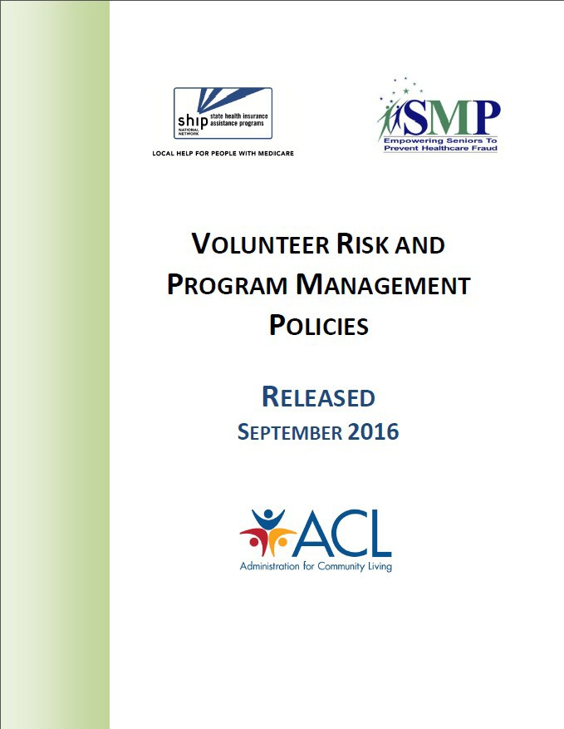
Volunteer Risk and Program Management (VRPM)

A volunteer program that is managed well is also likely to have less risk, and vice versa.
Today, we will focus on the concept of a well-run program instead of any specific policies.
ACL encourages you to consider how the volunteer policies and concepts might also apply to other team members.

Check-in Questions

- Have you worked for any organizations other than SHIP/SMP that involved volunteers?
- Have you ever managed a volunteer program before?
- Have you ever received any formal training in working with volunteers?
- Have you seen the Volunteer Involvement Cycle?

The Volunteer Involvement Cycle

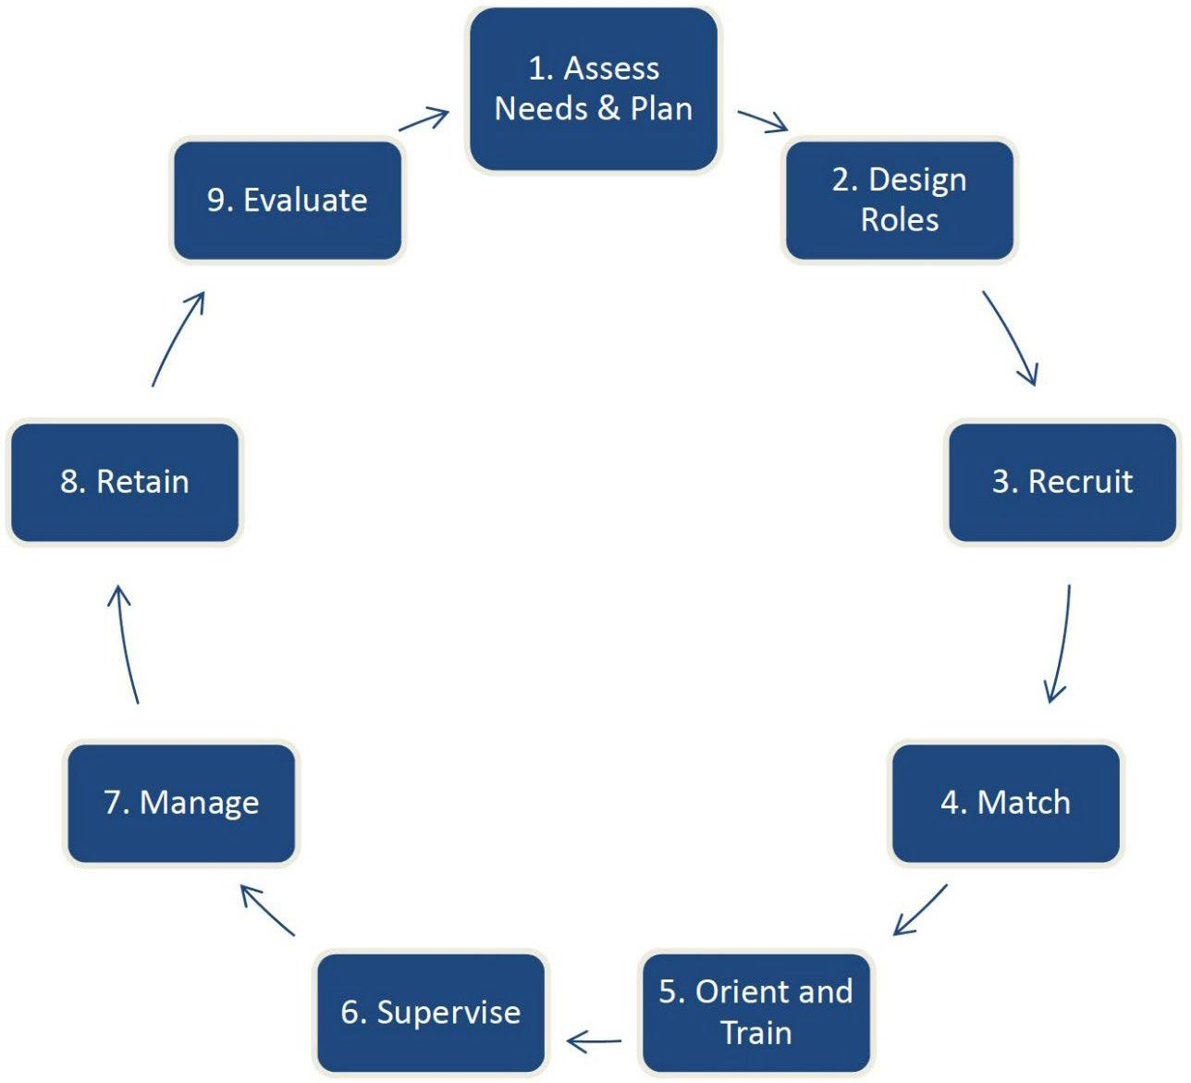
9

Volunteer Program Management Manual

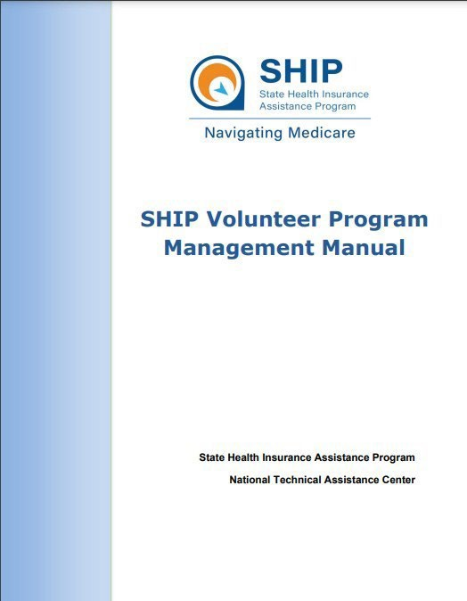
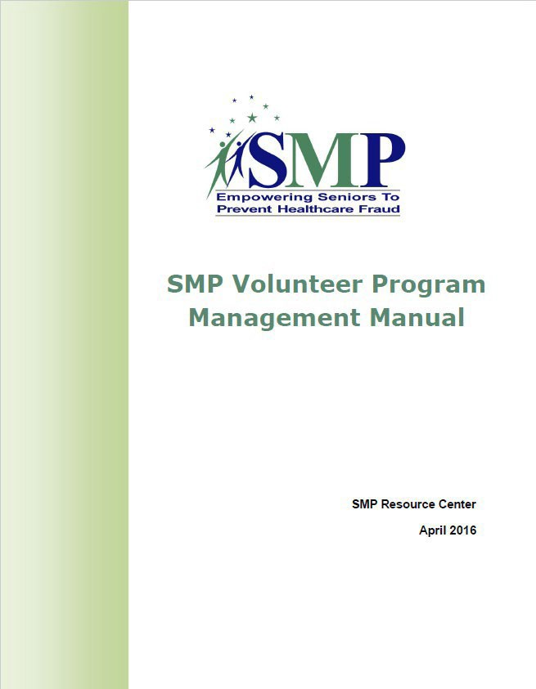
10

Role of the Coordinator of Volunteers
Sue Choplin

Role of the Coordinator of Volunteers (CoV)

Who is in charge?
Different structures. Not wrong, just different.

See the Volunteer Program Management Manual (p.9-11) referenced on slide 10 for more details.

- Single staff person manages all aspects of volunteer involvement
Poll: How is responsibility for managing volunteer involvement structured in your program?
When the polling has ended, click the arrow to re- open the Participants panel.
- Tasks are divided among program staff along task functions: screening, training, supervision, etc.
- Tasks are divided among program staff along geographic lines.
- Tasks are divided between SMP or SHIP staff and local partner agencies (VHOs)
- Other?

Networking

14

“Volunteer involvement depends upon creating a good system for working with volunteers. A program that has insufficient infrastructure, inadequate staff and leadership support, insufficient budgeting, or other defects in management will fail to attract and keep volunteers.”

15

Break Time!

Class will resume in 5 minutes…
When the polling has ended, click the arrow to re-open the Participants panel.
Please don’t get stuck at the water cooler!
Check in with the poll on the right when you’re back and ready to go.

Eight Things to Make Sure Happen No Matter What
Steve McCurley

Things to Pay Attention to No Matter Who is in Charge of Volunteer Involvement
OR…
A Cheater’s Guide to the Volunteer Involvement Cycle

18

- Emphasize ”word of mouth”
recruitment

19

Storytelling Examples: SHIP and SMP

SHIPs: www.shiphelp.org > Volunteer
SMPs: www.smpresource.org > You Can Help > Become a Volunteer

20

Continuously check your intake/initial contact system

21

- Monitor screening/
criminal records checks

22

4. Train everyone
who has any responsibility for working with volunteers

Check-in Questions

  - Do you provide training for program staff who work with volunteers?
  - Do you provide an orientation for all staff about the volunteer program, whether or not they work with volunteers?
  - Do you train local contractors (VHOs) in working with volunteers?
  - Does your SMP/SHIP provide a budget so that you can get training in working with volunteers?

- Be clear about
performance expectations and hold people to them: staff, volunteers, contractors

25

- Keep your focus on
retention, not recruitment

26

- Encourage social
interaction, team building, and bonding

27

Communicate, communicate, communicate

28

2
We cannot herd cats.

We can, however, learn to lead them so that they choose to follow.

SMPs SHIPs
Today’s webinar resources in the libraries

- Step 1: Login at www.smpresource.org (click the blue SMP Login padlock).
- Step 2: Search for keyword “manage”.
- Step 1: Login at www.shiptacenter.org (click the orange SHIP Login padlock).
- Step 2: Go to the Resource Library.
- Step 3: Search for keyword “manage”.

MIPPA grantees: Resources are emailed to the MIPPA listserv.

Additional resources in the libraries

- Volunteer Program Management Manual
- Volunteer Involvement Cycle
- Medicare Messenger articles, e.g.:
  - Why SMPs and SHIPs Should Involve Volunteers (January 2022)
Volunteer Management Resources
VRPM Resources
ACL’s VRPM Policies SMPs
VRPM Orientation VRPM Management Curriculum
(TRAX > Available Training)
SHIPs
VRPM Basic Training for SHIPs
VRPM Resource Groupings entry
- 3/24: Self-Care Strategies to Sustain You in Your Work
- 4/6: Recruiting and Retaining Volunteers Remotely
Upcoming Webinars

Questions and discussion

This project was supported, in part by grant numbers 90SATC0002 and 90MPRC0002 from the U.S. Administration for Community Living, Department of Health and Human Services, Washington, D.C. 20201. Grantees undertaking projects under government sponsorship are encouraged to express freely their findings and conclusions. Points of view or opinions do not, therefore, necessarily represent official Administration for Community Living policy.

Appendix D
Home Visit Considerations

Home Visit Considerations

The question of whether a home visit should occur involves consideration of several factors. A home visit can sometimes be the most time-effective means of obtaining necessary information from the client or applicant, and of providing necessary information to clients and applicants. The following list is not all-inclusive, but rather it states some of the pertinent considerations. No consideration, however, is more important than the health and safety of the client and the health and safety of AAA staff and volunteers. Any order that makes a home visit improper must be complied with.

- Has the client or the applicant for services requested a home visit or is it rather the AAA staff member or volunteer who believes a home visit is the most time-effective form of visit?
- Does the client or applicant, or the staff member or volunteer, have a disability that makes a home visit more, or less, appropriate?
- Will a home visit meet the need for confidentiality?
- Why is an in-office conference with the client or applicant, or gathering of information by tele- phone or video-teleconference or written correspondence, including questionnaire, checklist, fax (if available), or email (if available) not as time-effective as a home visit?
- What information or "clues" would a home visit allow to be obtained, that an in-office conference or other means of information gathering will not allow?
- Is photocopying likely to be necessary and does the client or applicant have a photocopy ma- chine in their home or is there one in a nearby office or business that can be used, so as to speedily return to the client or applicant the important papers, or is the amount of copying necessary small enough to be done by using the camera on a mobile phone or can the copying wait and be done in the office of the staff member or volunteer?
- Does the client or applicant have a member of the household who cannot be left in the home without the client or applicant also being in the home?
- Does the client or applicant have a member of the household or a family member or friend who can provide transportation for the client or applicant?
- Is another means of transportation available for the client or applicant to come to the office?
- Are there factors present in the location where the client or applicant stays that may require a home visit to involve more than one staff member or volunteer or that may rule out a home vis- it? Such factors to consider include, but are not limited to, dogs or other pets that may be dangerous, smoking, other occupants in the dwelling who have a criminal history or who have difficulty managing anger; whether an occupant of the dwelling has a communicable illness; and whether the dwelling is in good structural condition.
- Does the staff member or volunteer have a communicable illness, which it would be best to not expose the client or applicant to?
- Is the time-effectiveness of a home visit (which can sometimes be highly time-effective) out- weighed by the loss of time in the office?

As mentioned, no consideration, is more important than the health and safety of the client and the health and safety of AAA staff and volunteers. Any order that makes a home visit improper must be complied with. Subject to those caveats, nu m be r s 1 – 12 are merely some considerations. A home visit can be a very time-effective means of gathering information from clients and applicants, and of providing information to clients and applicants. The experience of clients and applicants that you serve, and your own AAA 's experience may give rise to other considerations and may cause some of the above to be eclipsed in importance by other considerations.

Appendix E

Client Intake and Service Request Form

Intake
Form 2276
October 2021-E

Area Agency on Aging of

The information on this form is needed to provide services. All information is confidential and will be guarded against unofficial use and shared only to get services started or changed.
*Release of Information and Client Rights and Responsibilities explained.

Note: All items marked with an asterisk (*) are required.
Part I – Recipient Identification
*Date: | SPURS ID No.: |  |  |  | Primary Language:
*Last Name: | *First Name: |  |  | *MI: | *Date of Birth: |  | *Gender:
*Street Address and Apt. No.: | *City: |  | *State: |  | *ZIP Code: |  | *County:
*Area Code and Phone No.:  Home | Email Address:
Check if Mailing Address is different from Home Address and enter Mailing Address below:
*Street Address and Apt. No. or P.O. Box: | *City: |  | *State: |  | *ZIP Code: |  | *County:
*Ethnicity (Check One):  Hispanic or Latino  Not Hispanic or Latino Unknown | *Race (Check all that apply): American Indian or Alaska Native Asian  Black or African American  Native Hawaiian or Pacific Islander Non-Minority (White, Non-Hispanic) White – Hispanic |  |  |  | Marital Status (Check One):  Married  Widowed Divorced Separated  Never Married  Not Reported
*Person lives alone?  Yes No Don't Know | Total No. of People in Household: |  |  |  | Monthly Household Income:
Use current Department of Health and Human Services Federal Poverty Guidelines for size of household to decide if person is at or below poverty. |  |  |  |  | *At or below poverty?  Yes No Don't Know
Monthly Income from: |  | Participant |  |  |  | Spouse
Job
Social Security
Supplemental Security Income
Veterans Affairs
Other Sources
Other Benefits [e.g., Supplemental Nutritional Assistance Program (SNAP)]

Form 2276
Page 2 / 10-2021-E

Part II – Service(s) Requested (Completed by AAA or provider staff)
List of Requested Services:
Are you enrolled in? Medicaid Medicare

Part III – Emergency Contact Information (Completed by AAA or provider staff)
Contact Name: | Relationship: | Area Code and Phone No.:
Primary Care Physician: |  | Area Code and Phone No.:
Part IV – Referral (Completed by AAA or provider staff)
Referred by:
*Name of AAA or Provider Staff Completing Intake
*Date

Part V – Nutrition Services (Completed by AAA or provider staff)
*Additional Eligibility Requirements if eligible person is under 60. Check which of the following applies: Eligible person is under 60 and the spouse of person 60 or older who takes part in the nutrition program.
Eligible person is under 60, serves as volunteer at the nutrition site and the provider offers a meal according to AAA procedures.

Eligible person is under 60, has a disability and lives in a housing facility occupied primarily by people 60 and over where congregate meals are served.
Eligible person is under 60, has a disability, lives with a person eligible for a meal and the provider offers a meal according to AAA procedures.

Formulario de admisión
Formulario 2276-S
Octubre de 2021-E

Agencia del Área para Adultos Mayores (AAA) de

La información en este formulario es necesaria para proporcionar servicios. Toda la información es confidencial, se protegerá contra el uso no oficial y solo se compartirá para iniciar o modificar los servicios.
*Se explicaron la Divulgación de información y los Derechos y responsabilidades del cliente.

Nota: Toda la información marcada con un asterisco (*) es obligatoria.
Parte I: Datos del beneficiario
*Fecha: | Núm. de ID de SPURS: |  |  |  | Idioma principal:
*Apellido: | *Primer nombre: |  | *Inicial del segundo nombre: |  | *Fecha de nacimiento: |  | *Género:
*Dirección y número de apartamento: | *Ciudad: |  |  | *Estado: | *Código postal: |  | *Condado:
*Teléfono con código de área:  Casa | Correo electrónico:
Marque la casilla si la dirección postal es diferente al domicilio y escriba la dirección postal a continuación:
*Dirección y número de apartamento o P.O. Box: | *Ciudad: |  |  | *Estado: | *Código postal: |  | *Condado:
*Grupo étnico (Marque uno):  Hispano o latino  Ni hispano ni latino Desconocido | *Grupo racial (Marque todos los que correspondan): |  |  |  | Estado civil (Marque uno):  Casado Viudo Divorciado Separado  Nunca se ha casado  No se indicó
 |  | Nativo americano o nativo de Alaska
 |  | Asiático
 |  | Negro o afroamericano
 |  | Nativo de Hawái o de las Islas del Pacífico
 |  | No minoritario (blanco, no hispano)
 |  | Blanco - hispano
*¿El beneficiario vive solo?  Sí No No se sabe | Núm. total de personas que viven en el hogar: |  |  |  | Ingresos mensuales del hogar:
Consulte la guía federal de pobreza actualizada del Departamento de Salud y Servicios Humanos para determinar, según el tamaño del hogar, si la persona se encuentra al nivel federal de pobreza o por debajo de este. |  |  |  |  | *¿Al nivel o por debajo del nivel de pobreza?  Sí No No se sabe
Ingresos mensuales: |  |  | Beneficiario |  |  | Cónyuge
Empleo
Seguro Social
Seguridad de Ingreso Suplementario
Asuntos de los Veteranos
Otras fuentes
Otros beneficios [por ejemplo, del Programa de Asistencia Nutricional Suplementaria (SNAP)]

Formulario 2276-S
Página 2 / 10-2021-E

Parte II: Servicios que se solicitan (Debe ser llenada por el personal de la AAA o del proveedor)
Lista de servicios que se solicitan:
¿Está inscrito en alguno de los siguientes programas? Medicaid Medicare

Parte III: Información del contacto de emergencia (Debe ser llenada por el personal de la AAA o del proveedor)
Nombre del contacto: | Relación: | Teléfono con código de área:
Médico de cabecera: |  | Teléfono con código de área:
Parte IV: Remisión (Debe ser llenada por el personal de la AAA o del proveedor)
Remitido por:
*Nombre del empleado de la AAA o del proveedor que llenó este formulario de admisión
*Fecha

Parte V: Servicios de nutrición (Debe ser llenada por el personal de la AAA o del proveedor)
*Requisitos de participación adicionales si la persona con derecho es menor de 60 años. Marque las casillas que correspondan:

El beneficiario es menor de 60 años, su cónyuge es mayor de 60 años y participa en el programa de nutrición.
El beneficiario es menor de 60 años, sirve como voluntario en el centro de nutrición y el proveedor ofrece una comida según los procedimientos de la AAA.
El beneficiario es menor de 60 años, tiene una discapacidad y vive en un centro residencial habitado principalmente por personas mayores de 60 años en el que se sirven comidas en grupo.
El beneficiario es menor de 60 años, tiene una discapacidad, vive con una persona con derecho a una comida y el proveedor ofrece una comida según los procedimientos de la AAA.

Appendix F

Client Rights and Responsibilities

Client Rights and Responsibilities
Area Agency on Aging of
Form 2275
March 2014-E

The Area Agency on Aging of welcomes you as a participant in programs for older individuals and family caregivers
in our region. This program is mandated by the Older Americans Act of 1965, as amended, and provides access and assistance and other supportive services. The programs and services are administered by the Area Agency on Aging with funding provided through the Texas Health and Human Services Commission, client contributions and local funding.

Programs and services are designed for individuals 60 or older and/or their family members and other caregivers. Our goal is to assist older individuals in leading independent, meaningful and dignified lives in their own homes and communities as long as possible through the provision of limited support services. Information will not be released to anyone, or any agency without your informed consent, with the exception of records subpoenaed by a court of law.

Client rights and responsibilities:
- You have the right to be treated with respect and consideration. You have the right to have your property treated with respect.
- You may not be denied services on the basis of race, religion, color, national origin, sex, disability, marital status, or inability and/or unwillingness to contribute.
- You have the right to make a complaint/grievance or recommend changes to policy or service, without restraint, interference, coercion, discrimination or reprisal. To make a complaint or grievance, contact the Area Agency on Aging. Contact information is identified below:

Service Provider Information | Area Agency on Aging Information

- You have the right to participate in the development of a care plan to address unmet needs.
- You have the right to be informed in writing of available services and the applicable charges if the services are not covered or are unavailable by Medicare, Medicaid, health insurance, or Older Americans Act funding.
- You have the right to make an independent choice of service providers from the list furnished by the Area Agency on Aging where multiple service providers are available and change service providers when desired.
- You have the right to be informed of any change in service(s).
- You have the right to make a voluntary, confidential contribution for services received through the Area Agency on Aging. Services will not be denied if an eligible participant is unable or chooses not to make a contribution. All contributions will be kept confidential and will be utilized to expand or enhance the service(s) for which they were provided.
- You have the responsibility to inform the Area Agency on Aging or its service provider(s) of your intent to withdraw from the program or any known periods of absenteeism when services will not be utilized.
- You have the responsibility to provide the Area Agency on Aging or its services provider(s) with complete and accurate information.
N/A

N/A

N/A N/A

N/A

I hold harmless this Area Agency on Aging program, its parent organization, funders, and the sponsoring state agencies for any liability arising out of the services provided in accordance with program guidelines.

Client Signature Date

Appendix G

Area Agency on Aging Client Information Release

Client Information Release
Area Agency on Aging of
Form 2277
March 2014-E

Individual's Name | Individual's ID
By signing this authorization, you are giving the Area Agency on Aging (AAA) permission to release all or part of your information provided, which includes health information. Failure to provide this authorization will result in limited service by the AAA. This release includes access to a continuum of service(s) available through the AAA or its providers.

Parts A, B and C are to be completed by the individual or personal representative.
I authorize the AAA to release my information to the following person or agency for the purpose(s) stated in Part A. My information will remain available to the person or agency indicated in accordance with the expiration event or date in Part B.

Parts A – Release of Information
I understand that my information may contain protected health information. Release my information to the following person or agency:
Any person or agency necessary to meet my service needs. Only the persons or entities identified:
Check one of the following: Release all of my information. Release only the following information:

Parts B – Purpose of Release
General: To assist in assessing, arranging and meeting individual service needs. Specific:
Expiration:
This authorization expires at the point of reassessment, where applicable, or within three years of effective date.
Parts C – Signature
Signature – Individual or Personal Representative Date
Check if you are signing for the individual and describe your authority to act for the individual on the following line:

Note: If the person requesting the release of information cannot sign his/her name, two witnesses to his/her mark (X) must sign below. Accept one witness signature in circumstances where it is not possible to obtain two witness signatures. Document the reason in the individual's file.

Signature – Witness Date

Signature – Witness Date
Notice to Individual:
- Once the authorization to release your information is granted, the AAA is not responsible for any redisclosure of the information by the recipient.
- You can withdraw permission you have given the AAA to use or disclose health information that identifies you, unless the AAA has already taken action based on your permission. You must withdraw your permission in writing.

Forma 2277-S
Marzo de 2014-E

Divulgación de información del cliente
Agencia del Área para Adultos Mayores de

Nombre de la persona | Identificación de la persona:
Al firmar esta autorización, usted da permiso a la Agencia del Área para Adultos Mayores (AAA) para divulgar toda o una parte de la información sobre usted, incluso la información médica. Si no firma esta autorización, la AAA limitará los servicios que le ofrece. Esta autorización de divulgación da acceso a una gama de servicios disponibles por medio de la AAA o sus proveedores.

El cliente o su representante personal debe llenar las Partes A, B y C.
Yo autorizo a la Agencia del Área para Adultos Mayores para que divulgue mi información a las siguientes personas o departamentos con el propósito indicado en la Parte A. La información estará disponible a la persona o al departamento indicado hasta el evento o la fecha de vencimiento anotados en la Parte B.
Parte A – Divulgación de información
Entiendo que la información puede contener información médica protegida. Divulguen mi información a la siguiente persona o departamento:
Cualquier persona o departamento necesario para satisfacer mis necesidades de servicios. Solo a las personas o entidades identificadas:
Marque una de las siguientes opciones: Divulguen toda mi información. Divulguen solo la siguiente información:

Parte B – Propósito de la divulgación
General: Ayudar a evaluar, coordinar y satisfacer las necesidades personales de servicios. Específico:
Vencimiento:
Esta autorización se vence al hacer una reevaluación, si aplica, o 3 años después de la fecha de vigencia.
Parte C – Firmas
Persona o Representante personal Fecha
Marque esta casilla si firmó en nombre de la persona y describa en el siguiente renglón su autoridad para actuar por la persona:

Nota: si la persona que pide la divulgación de información no puede firmar su nombre, dos testigos de su marca (X) tienen que firmar a continuación. Acepte la firma de un solo testigo cuando no es posible obtener la firma de dos testigos. Documente la razón en el expediente de la persona.

Testigo Fecha

Testigo Fecha
Aviso a la persona:
- Una vez que dé la autorización para divulgar su información, la AAA no se hace responsable de ninguna divulgación de la información de parte del destinatario.
- Usted puede retirar el permiso que le haya dado a la AAA para usar o divulgar información de salud que lo identifique a usted, a menos que la AAA ya haya tomado alguna acción basándose en su permiso. Tiene que retirar el permiso por escrito.

